Solution set

- Draw an IP datagram and know each of the fields.

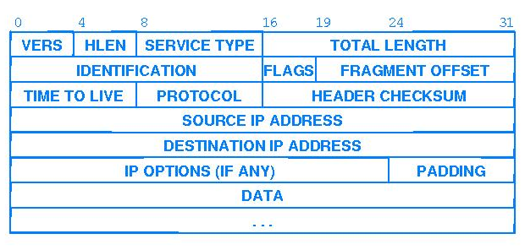

- Show how an IP packet is encapsulated in an Ethernet frame.

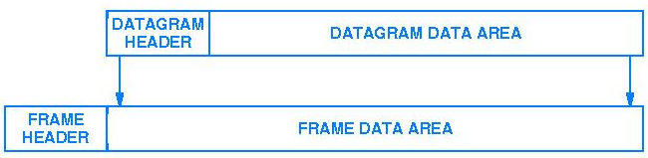

- HLEN defines the total length of the datagram header in 4-byte words. The length of the header varies between 20 and 60 bytes. When there are no options, the header length is 20 bytes, and the value of HLEN is 5 (5*4 = 20). When the option field is at its maximum size, the value of HLEN is 15 (15*4 = 60). An IP packet has arrived with the first 8 bits of 01000010. The receiver discards the packet. Why?

Solution:
There is an error in this packet. The 4 left-most bits (0100) show the version, which is correct. The next 4 bits (0010) show the header length, which means (2*4=8), which is wrong. The minimum number of bytes in the header must be 20.
This shows that the packet has been corrupted in transmission.

- The value of HLEN is 1000₂. How many bytes of options are being carried in this packet?

Solution:

The HLEN value is 8, which means the total number of bytes in header is 8*4 or 32 bytes. The first 20 bytes are the main header, the next 12 are the options.

- The value of HLEN is 5₁₆ and the value of the total length field is 0028₁₆. How many bytes of data are being carried in this packet?

Solution:

Total length is 40
Header length is 5*4=20
No. of bytes of data being carried is 40-20=20.

Fragmentation

- A packet has arrived with an M bit of 0. Is this the first fragment, the last fragment, or a middle fragment? Do we know if the packet was fragmented?

Solution:

If the M bit is 0, it means that there are no more fragmentations; the fragment is the last one. However we cannot say if the original packet was fragmented or not. A non- fragmented packet is considered the last fragment.

- A packet has arrived with an M bit of 1. Is this the first fragment, the last fragment, or a middle fragment? Do we know if the packet was fragmented?

Solution:

If M bit is 1, it means that there is at least one more fragment. This fragment can be the first one or the middle one, but not the last one. More information is needed to say whether it is the first or middle one but we can say that the original packet was fragmented because the M bit vale is 1.

- A packet has arrived with an M bit of 1 and a fragmentation offset value of zero. Is this the first fragment, the last fragment, or a middle fragment?

Solution:

As the M bit is 1, it is either a first or a middle fragment. Since the offset is 0, it is supposed to be first fragment.

Each fragment has exactly the same format as a complete diagram. The FRAGMENT OFFSET field specifies the offset in the original datagram of the data being carried in the fragment, measured in units of 8 octets, starting at offset 0. Datagrams are reassembled at the final destination where the fragments are put in order starting with the one with offset 0 through the highest offset.

- A packet has arrived in which the offset value is 100. What is the number of the first byte? Do we know the number of the last byte?

Solution:

To find the number of the first byte, we multiply the offset value by 8.This means that the first byte number is 800. Last byte cannot be determined unless we know the length of the data.

- A packet has arrived in which the offset value is 200, the value of HLEN is 5 and the total length field is 100. What is the number of the first byte and the last byte?

Solution:

The first byte number is 200*8=1600. The total length is 100 bytes and the header length is 20 bytes, which means that there are 80 bytes in this datagram. If the first byte number is 1600, then the last byte number must be 1679.

Time to Live

- An IP packet arrives with the first few hex digits as shown below:
45000028000100000102 …
How many hops can this packet travel before being dropped? To which upper layer protocol does this data belong?

Solution:

The packet can travel 1 hop before being dropped.
This data belongs to IGMP (Internet Group Management Protocol)

Options

- Are there any options in the previous packet?

Solution:

Yes, the above previous packet has options and this can be confirmed by calculating the header which is 20 and the total length is 40 then the difference is 20. The variable part is 20 that comprise options. The maximum length of variable part is 40.

